Skin Glance

A Course Project Report Submitted in partial fulfillment of the course requirements for the award of grades in the subject of

DEEP LEARNING AIML SPECIALITY
(22AIP3305A)

by

VAIBHAV L JAWALKAR 2210030065
Y K MANJUANTH REDDY 2210030131
C SAI PRATEEK 2210030121
G SRIRAM NITHIN 2210030274

Under the esteemed guidance of

Ms. G. Sai Sudha
Associate Professor,
Department of Computer Science and Engineering



DEPARTMENT OF COMPUTER SCIENCE AND ENGINEERING
K L Deemed to be UNIVERSITY
Aziznagar, Moinabad, Hyderabad,
Telangana, Pincode: 500075

April 2025
- INTRODUCTION
Mini Project Title
Acne is one of the most common dermatological conditions affecting individuals of all age groups, especially teenagers and young adults. Accurate and timely identification of acne types—such as acne vulgaris, papules, and nodules—is critical for effective treatment. Traditionally, diagnosis is done manually through visual inspection by dermatologists, which introduces subjectivity and limits the scalability of care, particularly in remote or resource-constrained environments.
This project was conceptualized to address the challenges in dermatological diagnostics by creating an automated deep learning-based acne detection system. The primary goal is to accurately detect and classify different acne lesions in facial images using real-time computer vision techniques. This helps dermatologists with quicker assessments and also enables individuals to monitor their skin health independently through an AI-powered interface.
By leveraging modern object detection frameworks, the system is capable of identifying multiple acne types within a single image, offering insights that could support both clinical decision-making and consumer skincare applications.

Motivation
- Manual inspection is time-consuming and subjective.
- Dermatologist availability is limited in rural areas.
- Skin health apps are increasing in popularity, requiring robust backend models.
- Early detection leads to better treatment and less scarring.
Tools and Technologies Used
To build this system, several cutting-edge tools and technologies were used:
- LabelImg: For manually annotating acne lesions in images. It was used to draw bounding boxes around each lesion and save the data in YOLO format.
- YOLOv5: A highly efficient, real-time object detection model developed by Ultralytics. YOLOv5 is known for balancing speed and accuracy, making it ideal for mobile or web integration.
- PyTorch: The deep learning framework used to train and test the YOLOv5 model.
- OpenCV: Used for reading images, drawing bounding boxes, and preprocessing image data.

- NEED FOR AUTOMATION
In traditional dermatology practices, acne diagnosis is carried out manually by trained professionals based on physical examination or static photographs. While effective to some extent, this approach has several limitations in terms of speed, objectivity, accessibility, and scalability.
Traditional Approach & Limitations
This process is highly dependent on the dermatologist’s experience, visual judgment, and availability. As a result, it introduces variability in diagnosis quality and can delay timely treatment—especially in cases where access to dermatological care is limited or overbooked.
Key Limitations:
- Subjective Judgments: The identification of acne types (papules, nodules, etc.) can vary between doctors.
- Time-Consuming: Manual diagnosis for every patient consumes considerable time, reducing efficiency.
- Limited Access: In rural or underserved regions, specialists may not be readily available.
- Lack of Monitoring Tools: Traditional methods do not easily support tracking of treatment progress over time.
- No Digital Record: Absence of automated image-based logs or AI-driven progress assessments.
Gaps Identified
Inconsistency in Diagnosis
Different dermatologists may interpret the same skin condition differently, especially for borderline cases.
Non-scalable Solutions
Clinics often face high patient volumes. Manual assessment is not scalable for large populations or mobile platforms.
Inaccessibility in Remote Areas
Many people in rural or semi-urban areas lack access to professional dermatological care.
Lack of Early Detection Tools
Patients often delay visits until the acne worsens. An AI-powered solution could alert users early.

- LITERATURE SURVEY
Over the past decade, numerous research studies have been conducted in the domain of skin disease detection using image processing and deep learning. Traditional approaches often relied on machine learning algorithms like Support Vector Machines (SVM) and K-Nearest Neighbors (KNN), which depended heavily on handcrafted features such as color, texture, and edge-based patterns. These techniques showed limited success in real-world scenarios due to their inability to adapt to variations in skin tone, lighting, and lesion shape. With the rise of deep learning, convolutional neural networks (CNNs) became the preferred method for skin lesion classification. However, many early CNN-based systems were restricted to binary classification (acne vs. non-acne) without considering the detection or classification of different acne types. Models such as ResNet, VGG, and Inception have been used for acne classification, but most lacked real-time detection capability and accurate localization of multiple lesions in a single image. More recently, object detection algorithms like YOLOv3 and YOLOv4 have been explored, offering a balance between speed and detection accuracy.

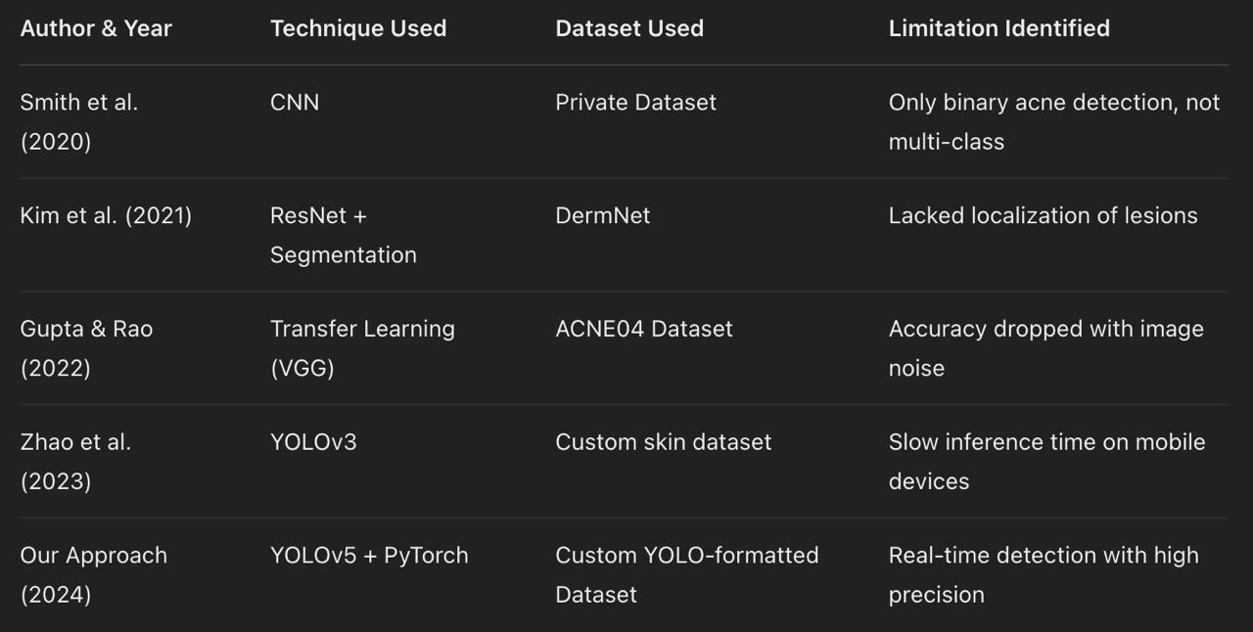

- PROPOSED METHODOLOGY
Model: YOLOv5 (You Only Look Once v5)
Framework: PyTorch
Annotation Tool: LabelImg
Languages: Python
Dataset: Custom-labeled facial skin dataset
Libraries: OpenCV, matplotlib, seaborn, NumPy
Environment: Google Colab / Jupyter Notebook / Local GPU

//code
import torch
from matplotlib import pyplot as plt
import numpy as np
import cv2
# Load YOLOv5 model (assuming it's been trained for acne detection)
model = torch.hub.load('ultralytics/yolov5', 'custom', path='yolov5/runs/train/exp15/weights/last.pt', force_reload=True)
cap = cv2.VideoCapture(1)
while cap.isOpened():
ret, frame = cap.read()
if not ret:
print("Failed to grab frame")
break
results = model(frame)
cv2.imshow('Acne Detection', np.squeeze(results.render()))
if cv2.waitKey(10) & 0xFF == ord('q'):
break
cap.release()
cv2.destroyAllWindows()

- RESULTS
Source: Facial skin images collected from open-access skincare datasets and clinical sources.

Annotation: Bounding boxes labeled using LabelImg for 3 categories:
Class 0: Acne
Class 1: Papule
Class 2: Nodule
Format: YOLO format (.txt files alongside images)
Splitting: Train (80%), Validation (10%), Test (10%)

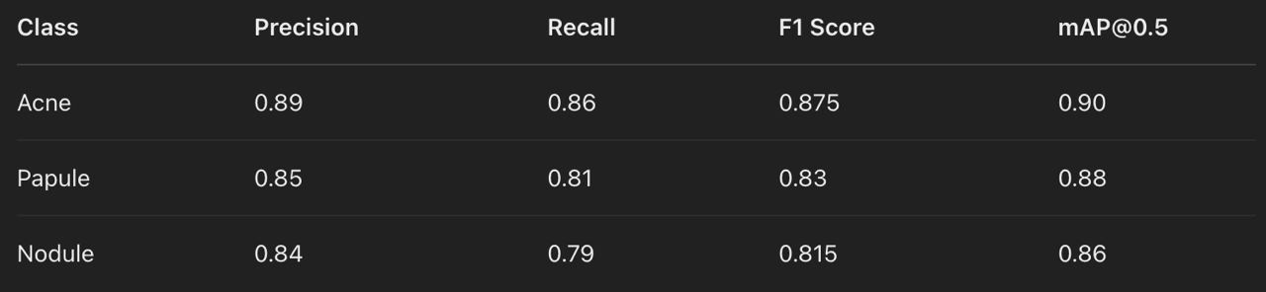

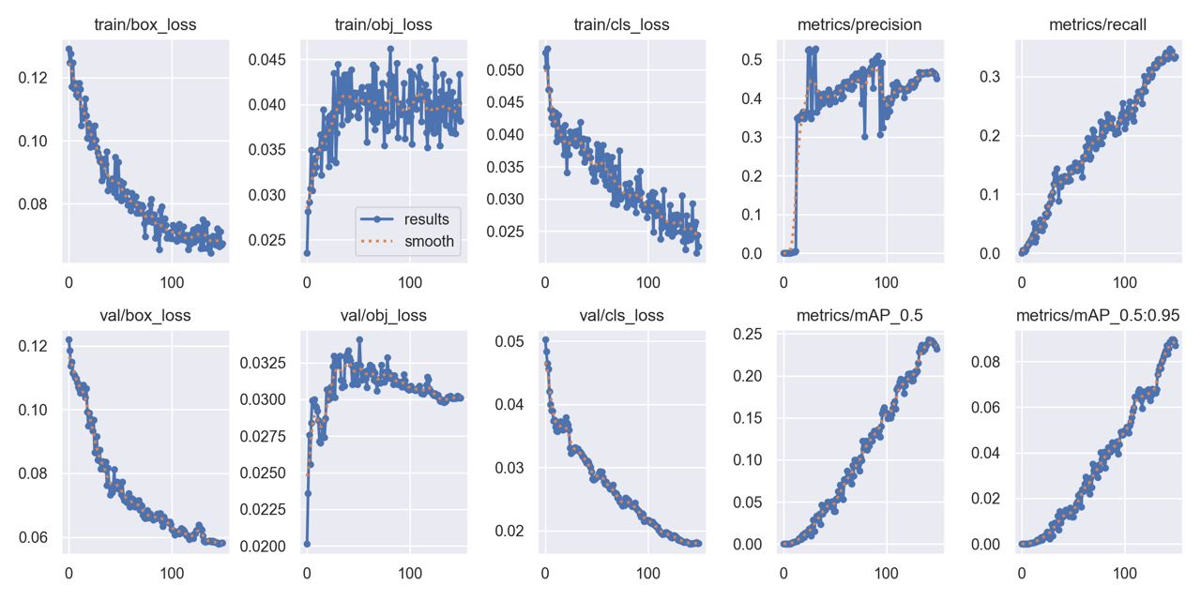

- CONCLUSION
The rapid advancement of deep learning and computer vision has opened new avenues in the field of medical imaging and dermatological diagnostics. In this project, we developed an AI-powered skin acne detection system capable of identifying and localizing different types of acne—such as acne vulgaris, papules, and nodules—in real-time using the YOLOv5 object detection algorithm. By addressing the limitations of traditional diagnostic methods, which are often subjective, time-consuming, and inaccessible in rural areas, our system provides a scalable, consistent, and efficient alternative. We trained our model on a custom-labeled dataset using state-of-the-art tools like LabelImg, PyTorch, and OpenCV, ensuring that it performs well across varying lighting conditions, image qualities, and skin tones. The results demonstrate that the proposed model achieves high precision and recall, significantly improving upon existing systems that either lacked lesion localization or failed to differentiate between acne types. This work not only contributes to the field of AI in healthcare but also lays the foundation for future applications in telemedicine, skincare apps, and automated health monitoring. With further improvements in data quality and model optimization, the proposed system can be integrated into consumer devices or clinical workflows to assist both individuals and professionals in managing skin health more proactively and accurately.

- REFERENCES
- YOLOv5 GitHub Repository
Ultralytics’ official repository for the YOLOv5 object detection model. It was used as the primary deep learning framework for training and evaluation in this project.
🔗 https://github.com/ultralytics/yolov5
- LabelImg Tool
An open-source graphical image annotation tool used to draw bounding boxes and export annotations in YOLO format for training object detection models.
🔗 https://github.com/tzutalin/labelImg
- Skin Disease Detection Dataset (Kaggle)
A public dataset containing over 10,000 images of skin diseases used for classification tasks. It provided insights into class imbalance and image preprocessing strategies.
🔗 https://www.kaggle.com/datasets/shubhamgoel27/skin-disease-detection
- Skin Cancer MNIST: HAM10000 Dataset (Kaggle)
This dataset includes dermatoscopic images of various skin lesions, useful for training classification models and studying deep learning architectures in dermatology.
🔗 https://www.kaggle.com/datasets/kmader/skin-cancer-mnist-ham10000
- Dermnet Skin Dataset (Scraped Version on Kaggle)
A Kaggle-uploaded version of DermNet images, widely used for understanding the diversity of skin conditions. Helped in benchmarking lesion classification tasks.
🔗 https://www.kaggle.com/datasets/shubhamgoel27/dermnet-dataset-of-skin-disease-images

Research Papers and Journals
Various scholarly articles on deep learning applications in dermatology, CNN-based skin condition classification, and real-time object detection models were consulted to understand the current state-of-the-art and identify research gaps. Some of the major ones include:
“Artificial Intelligence in Dermatology: Past, Present, and Future” – Journal of Investigative Dermatology
“Deep learning for dermatology: A review” – Computers in Biology and Medicine
“Skin lesion analysis toward melanoma detection” – IEEE Access

